L04_Hillary_Dreyer Bruton_ITAI2372

Proof of Completed Lab:

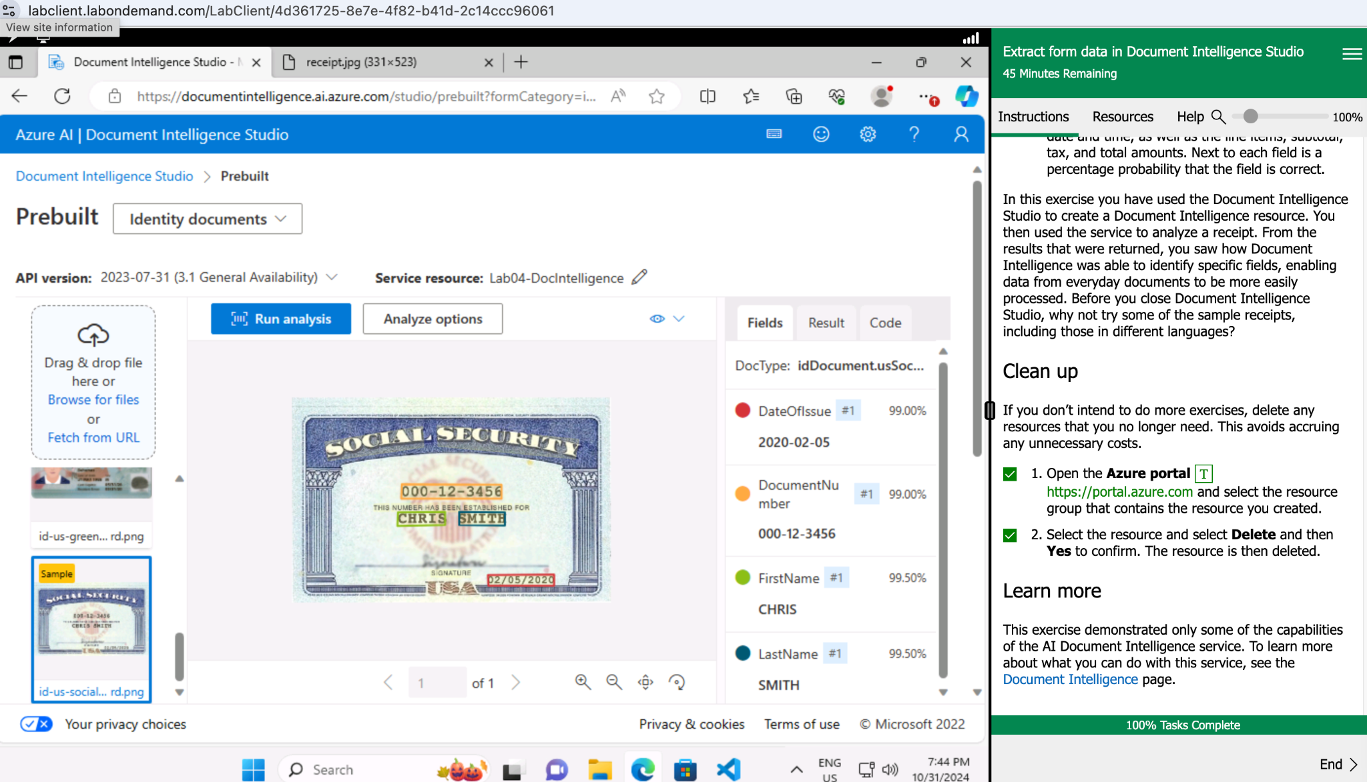

Lab 03 Reflective Journal:

What did I learn?

In this Lab, I gained hands-on experience with Document Intelligence Studio. The tool was designed to transform unstructured data, like documents and images, into usable information. It captures the layout and content of a document, can identify key-value pairs, extract data from tables and search the overall structure.

The lab focused on the exercise of analyzing a receipt from Northwind Traders. After completing the exercise, which was aimed at familiarizing the user with receipt analysis, I further explored the other prebuilt models available.

What were the challenges I faced?

I did not face any challenges in the lab as it contained clear instructions that were easy to follow.

What insights were gleaned?

My biggest takeaway from Lab 04 was the breadth of prebuilt models within Document Intelligence Studio. I was most impressed with its ability to scan and analyze documents in multiple languages.

Further, the ability to customize models to fit business use cases needs is very handy. I can envision this functionality being super helpful for capturing company-specific data, like field documentation or specialized forms. This experience sparked my curiosity about how the models performed with handwritten characters and handwritten shorthand. This could be very helpful for handling aging company records.